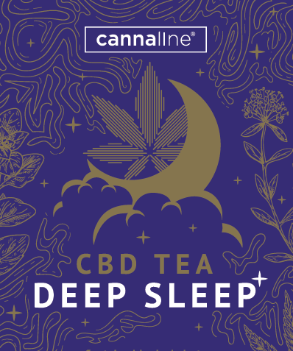**CBD TEA - DEEP SLEEP**

**GENERAL CHARAKTERISTIC**

## **Kind** Dietary supplement

**Packaging**  Tea, packed in filter bags. 20x1,5 g

**Weight netto** 30g

**Product line** CANNALINE

**Ingredients** Wild thyme herb *(Thymus serpyllum)* 25 %

Oregano herb *(Origanum vulgare)* 25 %

Lemon balm herb *(****Melissa officinalis)*** 25 %

St. Johns wort herb *(Hypericum perforatum)* 20%

Motherwort herb *(Leonurus cardiaca)* 5%

Hemp leaves *(Cannabis sativa)* 1%

**Preparation** Pour 250 ml of boiling water over 1 filter bag and let it infuse for 15 minutes.

**Note** The product is not intended for children. There is a possibility of photosensitization in sensitive persons. Do not exceed the recommended dosage. It is not intended as a substitute for a varied nutrition. Keep out of reach of children.

**Recommended dosage** 1 cup per day

**Storage condition** Store in a dry place at temperatures up to 25 °C.

**Shelf life** at least 24 months from production

**LOGISTICS**

**Sales packaging** 1 ks **dimension** 75x130x65 mm **EAN** 8594200570507

**Group packing**  10 ks **dimension** 150x130x325 mm

**(foil)**

**SENZORICS**

**Appearance** greenish brown to brown color of the infusion, clear or slightly cloudy

**Smell and taste** herbal, slightly bitter aroma and taste of the infusion, typical for the ingredients used

**QUALITY REQUIREMENTS**

**Humidity** max. 12%

**Microbiological limits** according to THIE´S recommendations for herbal infusions (dry)

Aerobic Plate Count ≤ 107 KTJ /g

Yeasts ≤ 105 KTJ /g

Moulds ≤ 105 KTJ /g

E.coli ≤ 103 KTJ /g

Salmonella absent in 125g

**Pesticides**

It meets the requirements of Regulation No. 396/2005 of the European Parliament and the Council on the maximum limits of pesticide residues in food and feed of plant and animal origin and on their surface.

**ALLERGENS**

According to Annex II of the Regulation of the European Parliament and of the Council (EU) No. 1169/2011 of October 25, 2011 on the provision of food information to consumers.

|  |  |  |  |  |
| --- | --- | --- | --- | --- |
| **LIST OF ALLERGENS** | | CONTAINS | MAY CONTAIN TRACES | PROCESSED IN THE FACTORY |
| 1 | Cereals containing gluten and products thereof | - | - |  |
| 2 | Crustaceans and their products | - | - | - |
| 3 | Eggs and egg products | - | - | - |
| 4 | Fish and fish products | - | - | - |
| 5 | Groundnut kernels (peanuts) and products thereof | - | - |  |
| 6 | Soybeans and products thereof | - | - |  |
| 7 | Milk and milk products (including lactose) | - | - | - |
| 8 | Nuts and their products | - | - |  |
| 9 | Celery and its products | - | - | - |
| 10 | Mustard and its products | - | - | - |
| 11 | Mustard and products thereof | - | - | - |
| 12 | Sulfur dioxide and sulphites in concentrations higher than 10 mg/kg or 10 mg/l | - | - | - |
| 13 | Lupine and its products | - | - | - |
| 14 | Molluscs and their products | - | - | - |

Date of last change: 06/04/2023